Individual Programme Plans

CONTEXT

There are certain accepted basic requirements concerned with health and well-being:

- physical needs, without which life itself cannot continue and
- psychological needs, without which an individual cannot attain contentment, self-reliance and good relationships with other people.

It is therefore essential to consider these needs when looking at providing a programme of activities designed to promote the health and well-being of our students.

Basic Physical Needs

Physical essentials for existence:

- Shelter and protective care.
- Food.
- Warmth and clothing.
- Fresh air and sunlight.
- Activity and rest.
- Prevention of illness and injury.
- Training in habits and skills necessary for the maintenance of life.

Basic Psychological Needs
These include:

- Affection and continuity of individual care.
- Security rooted in a knowledge of belonging, in stable personal relationships and in familiar environmental conditions.
- A sense of personal identity, dignity as a human being, and self-respect derived from knowledge of being valued as an individual
- Opportunity to learn from experience.
- Opportunity to achieve success in some field of endeavour, however small.
- Opportunity to achieve independence, personal and so far as possible, financial.
- Opportunity to take responsibility, however slight, and to be of service to others.

Consider these also in relation to Parity’s philosophy:

Equality, Dignity and Rights.

Values that underpin all services provided by Parity for Disability.
The Care Act 2014 adopts a ‘principled approach’ to adult social care, detailing from the outset that ‘the general duty of a local authority... in the case of an individual, is to promote that individual’s wellbeing’ (section 1:1)

The act defines ‘wellbeing’ in relation to any of the following:

a) personal dignity (including treatment of the individual with respect);
b) physical and mental health and emotional wellbeing;
c) protection from abuse and neglect;
d) control by the individual over day-to-day life (including over care and support, or support, provided to the individual and the way in which it is provided);
e) participation in work, education, training or recreation;
f) social and economic wellbeing;
g) domestic, family and personal relationships;
h) suitability of living accommodation;
i) the individual’s contribution to society.

John O'Brien's five major accomplishments:

Community presence | people should live, work and spend their leisure time in the community
Community participation | the service should offer real opportunities and ways for people with disability to participate in their local community and widen their network of personal relationships
Choice | the service should act as a creator and provider of maximum opportunity and choice and encourage the exercise of that choice
Competence | the service should always help and encourage people with disability to learn new skills and take on as much responsibility for themselves as possible
Respect | the service should strive to enhance the reputation of people with disability and present them in good light to others, so that they are viewed as having a valued role in the community and society as a whole.

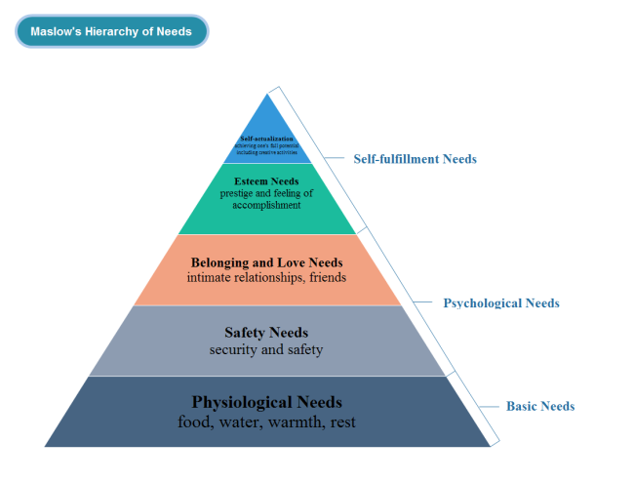

INDIVIDUAL PROGRAMME PLANS
(IPP)

Learning skills

Objectives should

Develop skills which help people to make sense of the world around them, ie develop learning skills.

Social and communication skills

Objectives should

Develop skills which help people to interact, form and maintain relationships

Independence skills

Objectives should

Develop skills which help people to operate effectively and as independently as possible in daily life (including decision making)

Leisure Activities

Objectives should

Identify opportunities for a wide selection of activities, to enable people to make constructive decisions about leisure activities.

