**Standing up for Myself (STORM):**

**End of Pilot Project Feedback and Celebration Event**

Tuesday 4 September 2018, 2pm to 5pm

UCL Room G12, 1-19 Torrington Place, London WC1E 7HB

|  |  |
| --- | --- |
| **Programme** | |
| **2.00-2.15**  **Katrina Scior, UCL**  *Welcome and overview of the Standing up for Myself (STORM) Project* | |
| **2.15 – 2.30** **Celia Brown, Paul Davies & Adrian Brown, Elfrida Society, Harry Roche,**  **Royal Mencap Society**  *Making sure STORM is right for its users: Our work as Self-Advocate Advisors* | |
| **2.30- 2.40** **Andy Minnion, Rix Centre, UEL & Lisa Richardson, UCL**  *The Rix Wiki version of the STORM manual* | |
| **Short interlude for those moving to Hands On sessions** | |
| **PARALLEL SESSIONS** | |
| **2.50-3.10 Lecture Theatre**  **Sophie Colman, UCL**  *Stigma and how people with learning disabilities feel about themselves and the world* | **2.50-3.10 Hands On session 1**  **Andy Minnion & Ajay Choksi, Rix Centre, UEL** *Hands-on Rix Wiki session*  OR  **Rebecca Cooper & Laurie Poole*,* UCL**  *STORM Taster activity* |
| **Short interlude to move between sessions** | |
| **3.10 – 3.30 Lecture Theatre**  **Kristina Fenn & Laurie Poole, UCL**  *The STORM pilot and feasibility study: Process and Results* | **3.10– 3.30 Hands On session 2**  **Andy Minnion & Ajay Choksi, Rix Centre, UEL** *Hands-on Rix Wiki session*  OR  **Rebecca Cooper & Sophie Colman**  *STORM Taster activity* |
| **3:35 – 4:00 TEA BREAK** | |
| **4.00- 4.15** **Franky Caffyn, Young Epilepsy**  *Running STORM for college students* | |
| **4.15- 4.25** **Bexley Mencap STORM Group Members**  *User experiences of STORM* | |
| **4.25- 4.30** **Niall Bradley & Ben Harper, Harpenden Mencap**  *‘After the STORM’* | |
| **4.30 – 4.45 Naomi Collett & Michael Childs, People First Dorset**  *Film on Hate Crime inspired by STORM* | |
| **4.45- 5.00** **Lisa Richardson & Katrina Scior, UCL**  *The Future of STORM* | |

**About**

The new STORM (Standing Up for Myself) programme is a manualised 4-session plus booster group-based intervention that seeks to empower people with learning disabilities to say ‘no’ to bad attitudes, prejudice and discrimination. STORM makes extensive use of filmed first-hand testimonials by people with learning disabilities, discussions and practical exercises. At this event we will present information about the STORM project and the pilot of the STORM intervention which we have completed. Talks will be given by members of the STORM research team, collaborators, self-advocate advisers, and STORM facilitators and participants. This event will be fully accessible to people with learning disabilities and is free to attend.

This project and event are supported by the Baily Thomas Charitable Fund.

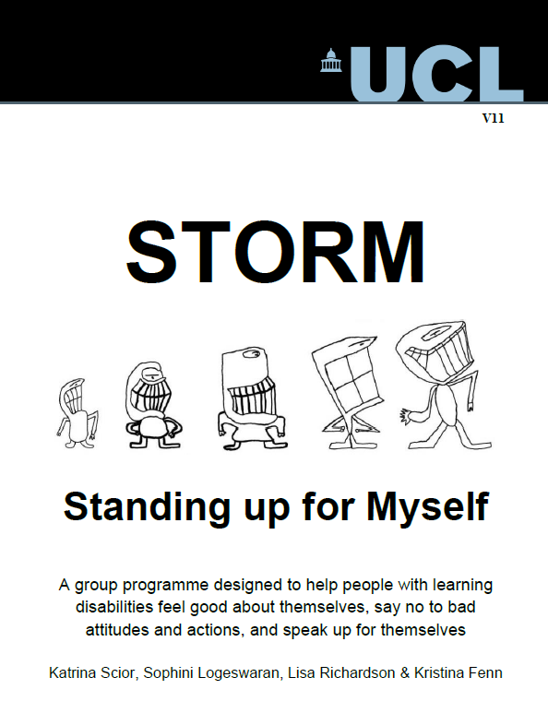

|  |  |
| --- | --- |
| **How to register:**  This is a free event however requires registering for a ticket via our Eventbrite site which can be accessed using the link below**:** |  |
|  |  |

<https://www.eventbrite.co.uk/e/standing-up-for-myself-storm-end-of-pilot-project-feedback-and-celebration-event-tickets-45755445770>