CONSENT FORM
Research Title: What is the experience of online negative comments for adults with a learning disability?

 |  | TICK
This Photo by Unknown Author is licensed under CC BY-SA | I am aged 18+
This Photo by Unknown Author is licensed under CC BY-NC-ND | The research has been explained to me.
This Photo by Unknown Author is licensed under CC BY | I have been able to ask questions about the research
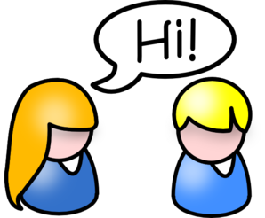 | I understand that I will talk about my bad experiences when on my computer, tablet, mobile phone or any other online thing I use e.g. PS4 in an interview.
 | I understand that I can stop being involved in this project if I want, before what I said starts being looked at and written about
 | My answers to the questions will be kept confidential and private.
 | I am happy to take part in the study
Signed: ___________________________________________________

Print Name: _______________________ Date____________________

Witness details (if present): __________________________________

