SUSTAINABLE

SOURCE

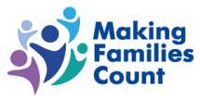 

Hello, we hope you are well. It has been a strange year, hasn’t it?



Maybe you’d like to talk about it?

`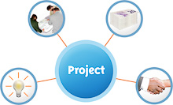

We’d like to invite you to a project Making Families Count and Sustainable Source are doing, funded by National Lottery Community Funding.



**What it’s about:**



**Telling your stories about being shielded**

**Lots of people with learning disabilities had to be shielded. If this was you, please get in touch.**

We want to hear your stories about what it’s been like for you.



 

Was it good or was it bad? Maybe a bit of both?

**We’d love you to tell your story to help doctors, nurses and care staff learn from you.**

**How can I tell my story?**

You can choose how you tell your story

 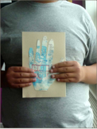

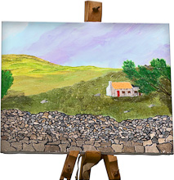 

You could paint a picture, write something, share photos or we can record your story on Zoom with you





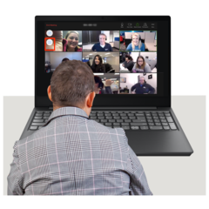

**Would you like to join us on our Zoom project?**



We are going to meet in the New Year **on 13th January 2021** to say hello

It’s a chance for everyone to find out more about the project, and how we will work together

Please bring a supporter if you’d like to

We are going to use art, photos and record your stories about being shielded



We will be meeting at 11 am

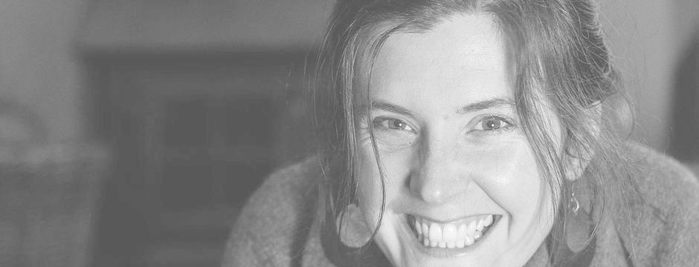

Ruth

Alex



**Who are we?**

Jan Sunman from Making Families Count and Alex Brooks with Ruth Shaw-Williams from Sustainable Source and we will support everyone

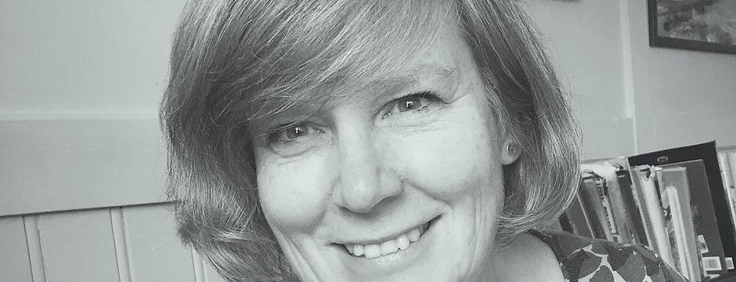

Jan



**We’re going to run 3 sessions in January and then have a special day to get together and share in February …**





**January 25th from 10.30 – 11.30 am**

**Will be a “Get to know Zoom session”**

**Start**

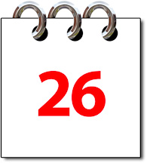

**Tuesday 26th January at 10.30 – 1 pm**

**Wednesday 27th January 10.30 – 1 pm**

**will be our session days**

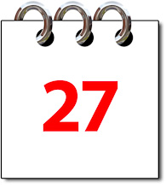



**Finish**

**Our Sharing Day:**

**February 24th 2021**



 

**Contact Jan**

**Via our weblink on:** [**https://bit.ly/MFCMSP**](https://bit.ly/MFCMSP?fbclid=IwAR3kpm8tUeAu2s_Q8YwDrX-wMJ-B1tCcvcxEOJqPt0eCozmc2iHwRl3yTcc)

Or by email: [info@makingfamiliescount.org.uk](mailto:info@makingfamiliescount.org.uk)

To find out about Making Families Count go to: [www.makingfamiliescount.org.uk](http://www.makingfamiliescount.org.uk)

To find out about Sustainable Source go to:

<https://www.sustainablesource.org.uk/our-story>