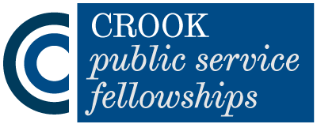
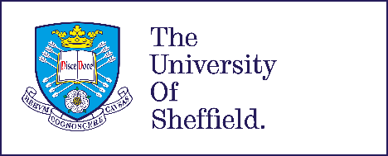

Dis/ability and Dis/advantage
The Crook Public Service Fellowship Showcase 2019
To be held at Franks & Steel Room,
The Wellcome Collection, 183 Euston Road, London, NW1 2BE
https://wellcomecollection.org/pages/WwabUiAAAHQXGNHB

On Thursday 27th November, 5.30-8.30pm

AGENDA

 | 5.30 pm | Arrival and refreshments  Williams Lounge
 | 5.50 pm | Welcome and introduction Professors Dan Goodley and Katherine Runswick-Cole  Move to Franks & Steel Room, next to the Williams Lounge
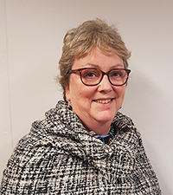 | 6.00 pm | Crook Fellow: Louise Wilkinson

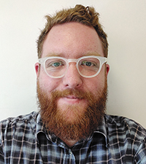 | 6.20 pm | Crook Fellow: Liam Toner
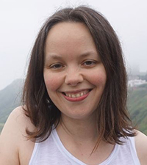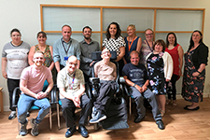 | 6.40 pm | Crook Fellow: Lucy Virgo and Sunderland People First
 | 7.00 pm | Chair's response, question and answer session, and panel discussion
 | 7.20 pm | Closing remarks and thanks  University of Sheffield
 | 7.30 pm | Drinks and networking  Williams Lounge
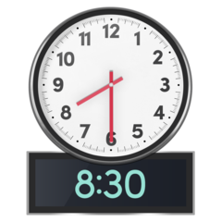 | 8.30 pm | Finish

